Lab: Arrays and Nested Arrays
Submit your solutions in the SoftUni judge system at:
https://judge.softuni.org/Contests/2752/Arrays-and-Nested-Arrays-Lab.

Arrays

Even Position Element
Write a function that finds the elements at even positions in an array.
The input comes as an array of string elements.
The output is printed on the console. Collect all elements in a string, separated by space.

Examples
Input | Output |  | Input | Output
['20', '30', '40', '50', '60'] | 20 40 60 |  | ['5', '10'] | 5

Last K Numbers Sequence
You are given two integers n and k. Write a JS function that generates and return the following sequence:
- The first element is 1
- Every following element equals the sum of the previous k elements
- The length of the sequence is n elements
The input comes as two number arguments. The first element represents the number n, and the second – the number k.
The output is the return value of your function and should be an array of numbers.

Example
Input | Output |  | Input | Output
6, 3 | [1, 1, 2, 4, 7, 13] |  | 8, 2 | [1, 1, 2, 3, 5, 8, 13, 21]

Explanation
The 2nd element (1) is the sum of the 3 elements before it, but there is only 1, so we take that. The third element is the sum of the first 2 (1 and 1) and the 4th – the sum of 1, 1, and 2. The 5th element is the sum of the 2nd, 3^{rd,} and 4th (1, 2, and 4) and so on.

Sum First Last
Write a function that calculates and returns the sum of the first and the last elements in an array.
The input comes as an array of string elements holding numbers.
The output is the return value of your function and should be a number.

Example
Input | Output |  | Input | Output
['20', '30', '40'] | 60 |  | ['5', '10'] | 15

Negative / Positive Numbers
Write a JS function that processes the elements in an array one by one and produces a new array. If the current element is a negative number you must add it to the front of the array (as the first element of the array). Otherwise, if the current element is a positive number (or 0), you must add it to the end of the array (as the last element of the array).
The input comes as an array of number elements.
The output is printed on the console, each element on a new line.

Example
Input | Output |  | Input | Output
[7, -2, 8, 9] | -2  7  8  9 |  | [3, -2, 0, -1] | -1  -2  3  0

Hints
- Write a function that receives an array as an argument.
- Declare variable named result that will keep the array.
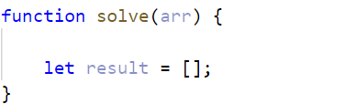
- You can use for loop to go around the items one by one.
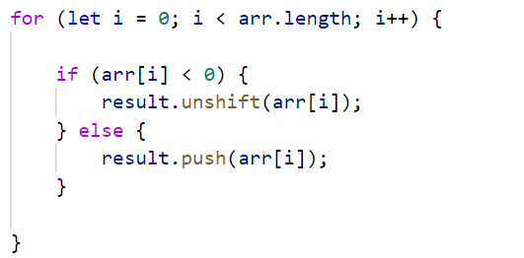
- If the current element is a negative number, you can use the unshift method to add the number at the beginning of the array.
- Otherwise, if the current element is a positive number (or 0), use a push method to add the number to the end of the array.
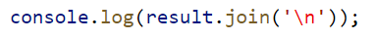
- Print on the console, each element of the array on a new line.

Smallest Two Numbers
Write a function that prints the two smallest elements from an array of numbers.
The input comes as an array of number elements.
The output is printed on the console on a single line, separated by space.

Example
Input | Output |  | Input | Output
[30, 15, 50, 5] | 5 15 |  | [3, 0, 10, 4, 7, 3] | 0 3

Bigger Half
You are given an array of numbers. Write a JS function that sorts the array in ascending order and returns a new array, containing only the second half of the input. If there is an odd number of elements in the input, always take the bigger half. For example, if the input array contains 4 elements, the output should be 2, and if the input is 5 – the output is 3.
The input comes as an array of number elements.
The output is the return value of the function and should be an array of numbers.

Example
Input | Output
[4, 7, 2, 5] | [5, 7]
[3, 19, 14, 7, 2, 19, 6] | [7, 14, 19, 19]

Piece of Pie
Write a function that receives three parameters – an array of pie flavors as strings, two target flavors as strings. The result of the function should be a new array, containing a section of the original array, starting at the first flavor parameter, and ending at (and including) the second flavor parameter.
The input comes as three arguments:
- An array of strings, representing pie flavors
- Two more strings, representing the start and end of the section, respectively
The output is the return value of the function and should be an array of strings.

Example
Input | Output
['Pumpkin Pie',  'Key Lime Pie',  'Cherry Pie',  'Lemon Meringue Pie',  'Sugar Cream Pie'],  'Key Lime Pie',  'Lemon Meringue Pie' | ['Key Lime Pie',  'Cherry Pie',  'Lemon Meringue Pie']
['Apple Crisp',  'Mississippi Mud Pie',  'Pot Pie',  'Steak and Cheese Pie',  'Butter Chicken Pie',  'Smoked Fish Pie'],  'Pot Pie',  'Smoked Fish Pie' | ['Pot Pie',  'Steak and Cheese Pie',  'Butter Chicken Pie',  'Smoked Fish Pie']

Process Odd Positions
You are given an array of numbers. Write a JS function that returns the elements at odd positions from the array, doubled and in reverse order.
The input comes as an array of number elements.
The output is the return on the console on a single line, separated by space.

Example
Input | Output |  | Input | Output
[10, 15, 20, 25] | 50 30 |  | [3, 0, 10, 4, 7, 3] | 6 8 0

Nested Arrays

Biggest Element
Write a function that finds the biggest element inside a matrix.
The input comes as an array of arrays, containing number elements (2D matrix of numbers).
The output is the return value of your function. Find the biggest element and return it.

Examples
Input | Output |  | Input | Output
[[20, 50, 10],  [8, 33, 145]] | 145 |  | [[3, 5, 7, 12],  [-1, 4, 33, 2],  [8, 3, 0, 4]] | 33

Diagonal Sums
A square matrix of numbers comes as an array of arrays, each array holding numbers. Write a function that finds the sum at the main and the secondary diagonals.
The input comes as an array of arrays, containing number elements (2D matrix of numbers).
The output is printed on the console, on a single line separated by space. First print the sum at the main diagonal, then the sum at the secondary diagonal.

Example
Input | Output |  | Input | Output
[[20, 40],  [10, 60]] | 80 50 |  | [[3, 5, 17],  [-1, 7, 14],  [1, -8, 89]] | 99 25

Equal Neighbors
Write a function that finds the number of equal neighbor pairs inside a matrix of variable size and type (numbers or strings).
The input comes as an array of arrays, containing string elements (2D matrix of strings).
The output is the return value of your function. Save the number of equal pairs you find and return it.

Example
Input | Output |  | Input | Output
[['2', '3', '4', '7', '0'],  ['4', '0', '5', '3', '4'],  ['2', '3', '5', '4', '2'],  ['9', '8', '7', '5', '4']] | 1 |  | [['test', 'yes', 'yo', 'ho'],  ['well', 'done', 'yo', '6'],  ['not', 'done', 'yet', '5']] | 2

